SIMATS ENGINEERING
SAVEETHA INSTITUTE OF MEDICAL AND TECHNICAL SCIENCES
PROGRAMMING IN JAVA - CSA0918
ASSIGNMENT 4 – CO4
EVENT-DRIVEN GUI DESIGN
Submitted by
GONUGUNTA AJAY KUMAR
Register Number: 192372300
GitHub Repository: [PASTE YOUR REPOSITORY URL HERE]
Academic Year: 2026–2027

Task 1 – GUI Design Review (6 Marks)

1.1 Design deficiencies
Deficiency | What can go wrong / user impact
UI and business logic are mixed | The event handler performs parsing, database access and payment work. The window is difficult to test and maintain.
String comparison uses == | String references are compared rather than text values. The Pay branch may not run reliably; use equals().
No input validation | Empty registration numbers, malformed amounts, negative values or non-finite numbers can cause exceptions or invalid payments.
Database work on event-dispatch thread | The UI freezes while the database responds. The user may think the application has stopped.
Thread.sleep(3000) on event thread | The window cannot repaint or process input during the delay.
No useful user feedback | System.out.println is not visible feedback in a GUI. Show a status label or dialog.
Receipt button is not implemented | The user clicks Receipt but no receipt is generated or shown.
Unsafe SQL concatenation | Input can break the SQL statement and create SQL injection risk. Use PreparedStatement.
Resources are not closed | Connections and statements can leak; use try-with-resources.
Window close handling is absent | The window may close without confirming an in-progress payment or cleaning up resources.
Checked exceptions are not handled | SQLException and InterruptedException must be handled or propagated appropriately.

1.2 Repaired design
The FeeWindow class is responsible only for collecting input and presenting status. FeeService validates the registration number and amount and coordinates payment. A production implementation should call a FeeDAO that uses PreparedStatement and transaction handling. Long-running bank/database work should be executed in SwingWorker so the Event Dispatch Thread remains responsive.
Class structure: FeeWindow → FeeService → FeeDAO → Database. FeeWindow sends the entered values to FeeService; FeeService validates them and returns a result object; FeeWindow displays the result. The repository contains a runnable FeeWindow and FeeService demonstration.

1.3 Design defence
Separating the interface from payment rules makes each class easier to test. FeeService can be tested without opening a window, while FeeWindow can be checked for correct display and event wiring. Changes to the layout do not require rewriting payment validation, and changes to payment rules do not require modifying button code.

Alternative listener and complexity
With one listener and an if–else chain, dispatch may perform up to k action-command comparisons, giving O(k) worst-case selection work. With a dedicated listener or Action per button, dispatch is direct and approximately O(1) after event registration, but k listener objects require O(k) additional space. In practice, event dispatch overhead is small; separation and maintainability are the stronger reasons to use dedicated actions.
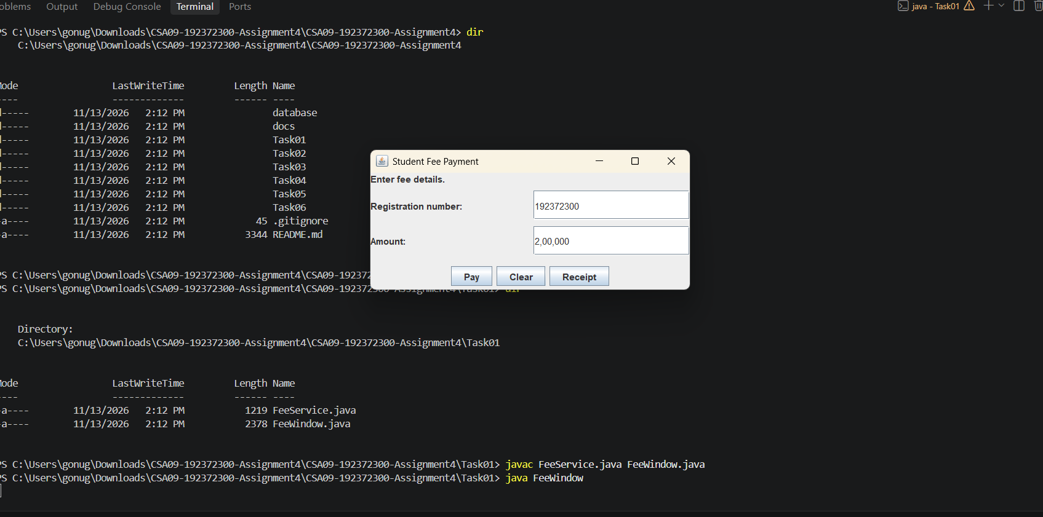

Task 2 – Hospital Outpatient Appointment Desk (8 Marks)

2.1 Event model
Event source | Event object | Listener | Action
Department JComboBox | ItemEvent | ItemListener | Refresh the doctor list for the selected department.
Doctor JComboBox | ItemEvent | ItemListener | Record the selected doctor.
Time-slot JComboBox | ItemEvent | ItemListener | Record the selected time slot.
Book JButton | ActionEvent | ActionListener | Validate fields and book the appointment.
Window close | WindowEvent | WindowAdapter / WindowListener | Ask for confirmation if booking is in progress.

2.2 Component hierarchy
JFrame (AppointmentDesk) contains a main JPanel using BorderLayout. Its centre contains a form JPanel using GridLayout(4,2): patient ID JLabel/JTextField, department JLabel/JComboBox, doctor JLabel/JComboBox and time slot JLabel/JComboBox. A FlowLayout panel contains Book and Clear buttons. A status JLabel displays confirmation or errors.

2.3 Handler pseudocode
RefreshDoctors: remove all existing doctor items; obtain the selected department; read its doctor list from doctorMap; add each doctor to the combo box; enable the doctor combo only when the list is non-empty.
BookAppointment: reject an empty patient ID; reject missing department, doctor or time slot; prevent a second booking while one is in progress; set bookingInProgress; validate availability and save through the service; display confirmation or error; clear bookingInProgress in a finally-style completion path.

2.4 Event trace and applet comparison
Construct the frame → create components → register listeners → set size and visibility → department selection generates ItemEvent → ItemListener refreshes doctors → Book click generates ActionEvent → ActionListener validates and books → close request generates WindowEvent → windowClosing asks for confirmation when required → dispose closes the frame.
An applet uses the lifecycle callbacks init(), start(), paint(), stop() and destroy(). A desktop JFrame does not use that applet lifecycle; it is created by application code and responds to window events such as windowOpened, windowClosing and windowClosed.
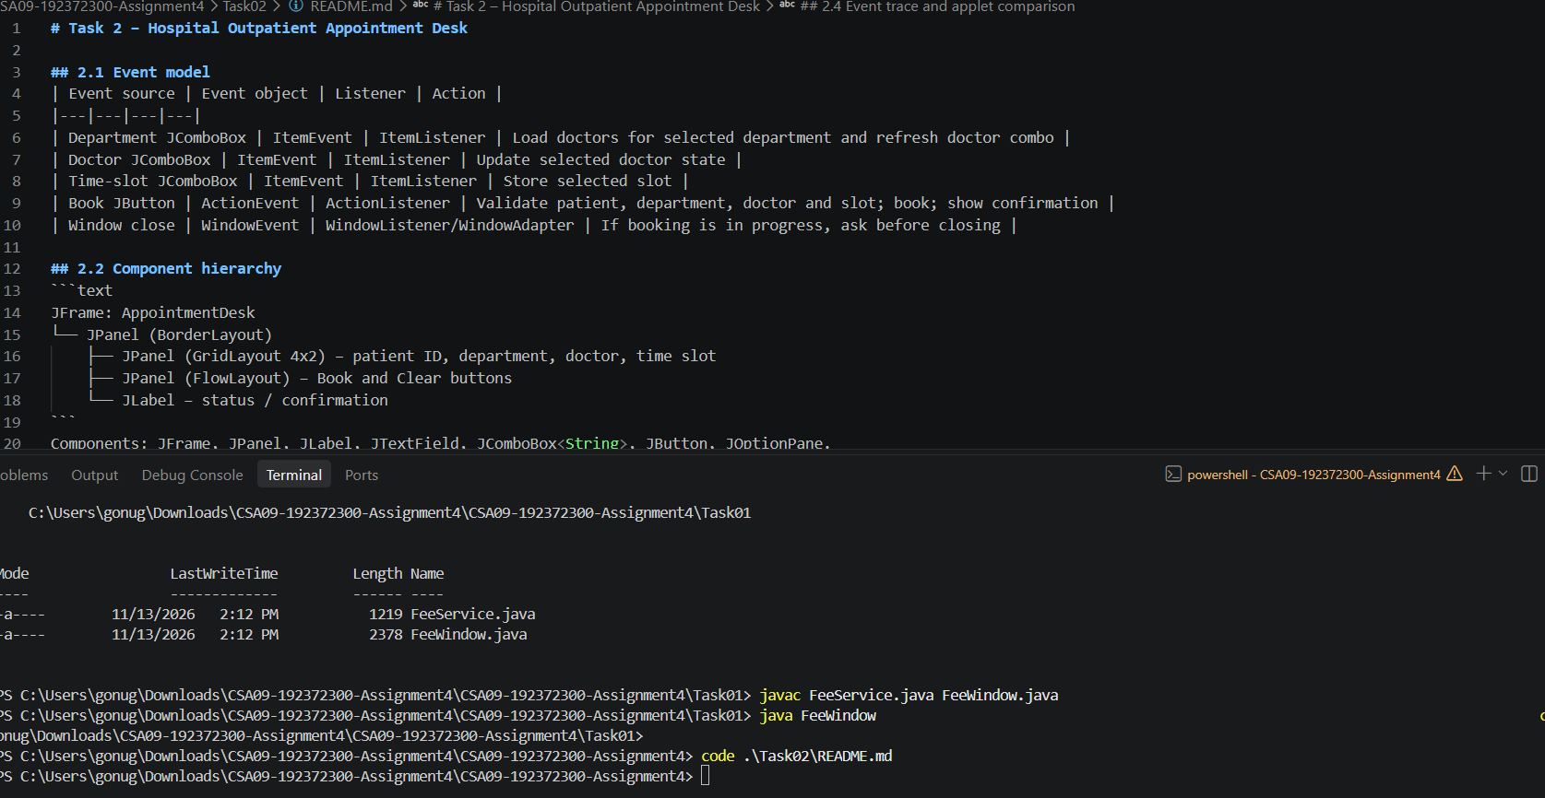

Task 3 – Campus Library Search Screen (9 Marks)

3.1 Layout choices
Region | Layout | Reason
Main frame | BorderLayout | Separates top, centre and bottom regions; centre receives extra space.
Search row | FlowLayout | Keeps the search field, category and Search button together at preferred sizes.
Results area | BorderLayout centre + JScrollPane | Expands when the window grows and supports scrolling.
Bottom controls | FlowLayout | Keeps Prev, Next and Reserve buttons at preferred sizes.

3.2 Nested panel structure
JFrame uses BorderLayout. NORTH contains the title label. CENTER contains a panel using BorderLayout: search row in NORTH and JScrollPane/results in CENTER. SOUTH contains a bottom panel using BorderLayout: button row in CENTER and status message in SOUTH.

3.3 Implementation and 3.4 resizing test
Task03/LibrarySearchUI.java implements the screen. It uses Swing components, a FlowLayout search row and a central JScrollPane inside BorderLayout. Run it and capture three screenshots at small, medium and large sizes. The expected behaviour is that the results region expands while the search row and bottom buttons retain their preferred sizes.

Alternative layout and complexity
GridBagLayout offers precise constraints and flexible resizing but requires more constraint configuration. Absolute positioning with setLayout(null) and setBounds() has little layout computation but does not adapt well to resizing, font changes or different display scaling. Nested BorderLayout/FlowLayout uses a small number of containers and predictable resizing. Layout calculation is generally proportional to the number of child components; container-object storage is O(c) for c containers in either design.
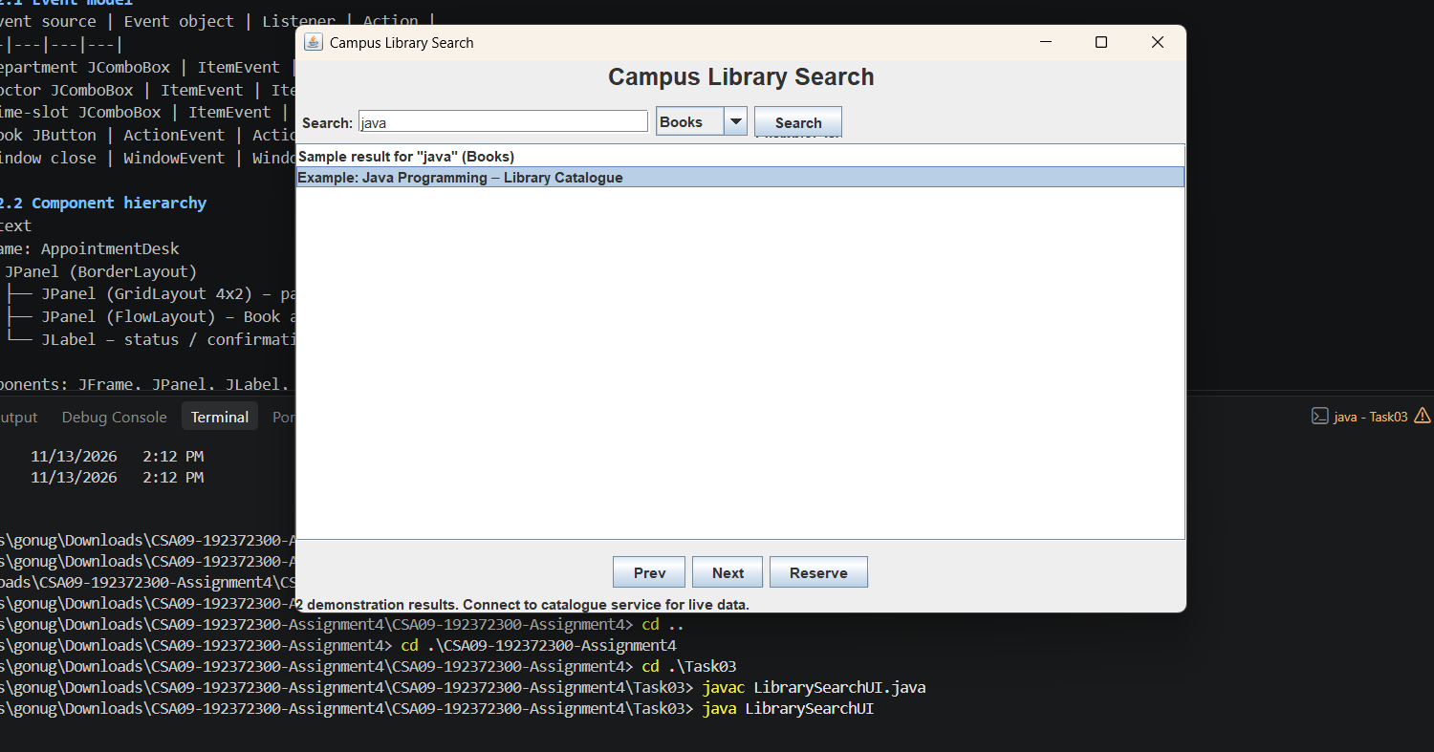

Task 4 – Event-Handling Forensics (7 Marks)

4.1 Defect
The method is written mouseclicked rather than mouseClicked. Java method names are case-sensitive, so it does not override MouseAdapter.mouseClicked and the callback is never invoked. The label is not updated because the intended callback never runs and the original code contains no label update.

4.2 Failing interaction
After correcting the callback, click several locations to draw dots, then minimise and restore the window or resize it. Dots drawn directly with getGraphics() disappear because the operating system may request a repaint and the temporary drawing is not part of the component's persistent state.

4.3 Repair and 4.4 prevention
Store each click as a Point in a List<Point>, update the label with the list size, call repaint(), and override paint(Graphics) to draw every stored point as a 6×6 filled circle centred at the point. The @Override annotation makes the misspelled method a compile-time error because it does not override a superclass method.
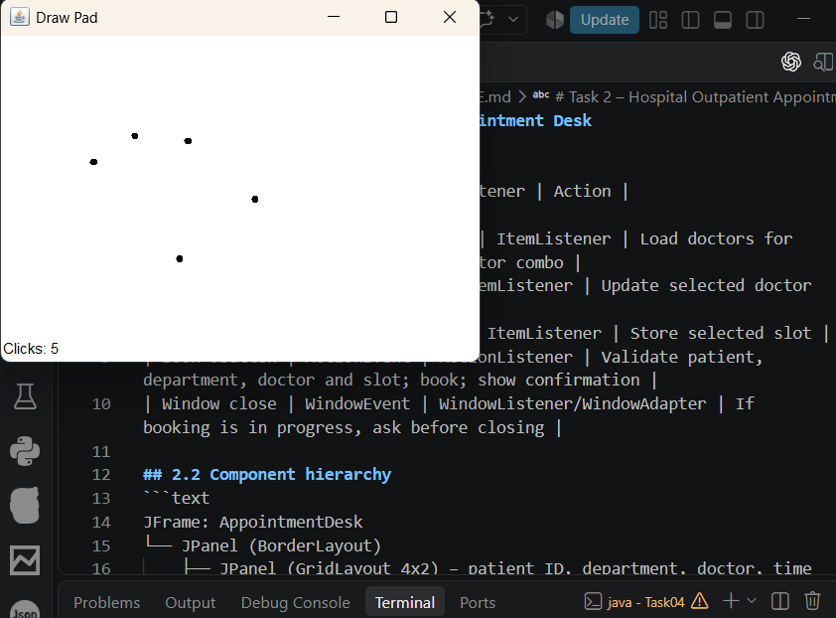

Task 5 – Event-Handling Styles (7 Marks)

5.1 Four implementations
The Task05/src folder contains four runnable implementations: ConverterFrameListener (frame implements ActionListener), ConverterNamedInner (named inner class), ConverterAnonymous (anonymous inner class) and ConverterLambda (lambda expression). Each also responds to Enter in the amount field and uses WindowAdapter for closing.

5.2 Changed requirement
The same conversion action is registered with both the Convert button and the amount field. All four versions display the converted value in a dialog and show an Invalid amount dialog when parsing fails.

5.3 Comparison
Style | Readability | Field access | Reuse | Change effort
Frame listener | Simple for small windows; may become crowded | Direct | Low; frame itself is handler | Moderate when more actions are added
Named inner class | Explicit and organised | Direct access to outer fields | Good within the enclosing class | Low for extending handler logic
Anonymous inner class | Self-contained but verbose | Direct access | Limited; unnamed local object | Moderate
Lambda | Concise for short single-method handlers | Can access enclosing fields | Good when shared variable is registered on multiple sources | Low for simple changes
For a large application, use separate Action classes or controller/service objects rather than placing substantial business logic in the frame. A shared Action is especially useful when one command must be triggered by a button, menu item and keyboard shortcut.

Completed lambda program and complexity
Task05/src/ConverterLambda.java completes both TODOs. It uses one shared ActionListener lambda for the button and Enter key, parses the amount, checks that it is finite and non-negative, formats to two decimal places and shows a dialog.
A method reference such as this::convert is compatible with ActionListener only if convert accepts an ActionEvent parameter; otherwise use a lambda wrapper. A shared Action object avoids duplicating command behaviour across buttons, menus and shortcuts. The number of listener/action objects is O(t) for t independently created triggers, or one shared Action plus trigger bindings when reused.
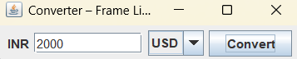

Task 6 – Campus Event Registration Desktop Application (13 Marks)

6.1 Requirements
- Users: students register for campus events; committee members view, filter and export registrations.
- Screens: registration form and registrations table, with File and Help menus and feedback dialogs/status.
- Data: student ID, student name, event name, registration ID and timestamp.
- Rules: reject invalid input; prevent the same student registering twice for the same event; keep database work off the Event Dispatch Thread.
- Testable requirement: a valid new student/event pair is saved and appears in the table.
- Testable requirement: invalid input is rejected with a clear message.
- Testable requirement: a duplicate student/event pair is rejected by a database uniqueness constraint.
- Testable requirement: event filtering and page navigation return the requested subset.

6.2 Screen and event flow
The main JFrame contains a JMenuBar with File (Refresh, Exit) and Help (About), a registration form with student ID, name and event selection, Register button, event filter, Apply Filter, Previous and Next buttons, and a JTable inside JScrollPane. Registration and filter actions update the table and status. Validation/database errors appear in a dialog.

6.3 Critical design decisions
Input validation belongs in RegistrationService. Duplicate prevention is enforced authoritatively by a UNIQUE(student_id,event_name) database constraint, with the duplicate-key error translated into a clear message. SQL access belongs in RegistrationDAO and uses PreparedStatement. SwingWorker performs insert and paginated select operations in the background; its done() method updates Swing components on the Event Dispatch Thread.

6.4 Class design and pseudocode
EventRegistrationApp is the presentation layer; RegistrationService contains application validation; RegistrationDAO performs JDBC operations; DB creates configured connections; Registration is a data model.
Register pseudocode: read form values; validate ID/name/event; disable relevant controls; execute service.register in SwingWorker.doInBackground; in done(), show success or error, clear fields after success and refresh the table.Filter pseudocode: read selected event; set page to zero; start SwingWorker; call DAO page(event, pageSize, page×pageSize); on completion clear table model and add returned rows; update status.

6.5 Implementation and test evidence
Task06 contains the layered Swing/JDBC application. The SQL script creates the campus_events database and registrations table with a unique constraint. The DAO uses parameterised SQL and LIMIT/OFFSET pagination. The UI uses SwingWorker for database work and provides CSV export of the currently displayed page.
Test | Input/action | Expected result
Valid registration | New valid student ID, name and event | Saved successfully and displayed in table.
Invalid ID | Blank or malformed student ID | Clear validation message; no database row inserted.
Invalid name/event | Too-short name or no event selected | Clear validation message; no database row inserted.
Duplicate | Register same student ID for same event twice | Second insert rejected by unique constraint and friendly message.
Filter | Choose one event and Apply Filter | Only matching event rows displayed.
Pagination | Click Next/Previous | Different page retrieved using LIMIT/OFFSET.
Responsiveness | Load/insert while moving or repainting the window | Window remains responsive because JDBC runs in SwingWorker.

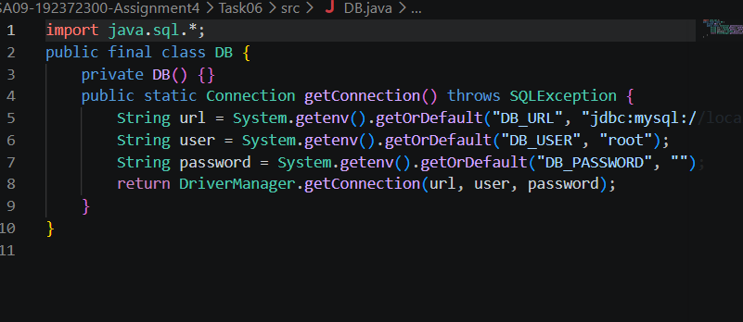

Conclusion
This assignment helped in understanding and implementing the important concepts of event-driven programming in Java. Through the six tasks, different GUI applications were designed using AWT and Swing components, event listeners, adapter classes, inner classes and lambda expressions. The assignment also provided practical knowledge of handling user interactions, arranging GUI components using layout managers, validating user inputs and managing events efficiently. The DrawPad and Currency Converter tasks demonstrated different approaches to event handling, while the Campus Event Registration System introduced database connectivity using JDBC and MySQL. Overall, this assignment improved practical programming skills and provided a better understanding of developing interactive, user-friendly and database-connected Java desktop applications.

References
- Herbert Schildt, Java: The Complete Reference, 12th Edition, McGraw Hill.
- Oracle, The Java Tutorials – Creating a GUI With Swing. https://docs.oracle.com/javase/tutorial/uiswing/
- Oracle, The Java Tutorials – AWT and Event Handling. https://docs.oracle.com/javase/tutorial/uiswing/events/
- Oracle, Java SE Documentation. https://docs.oracle.com/en/java/
- Oracle, JDBC Basics – Java Database Connectivity. https://docs.oracle.com/javase/tutorial/jdbc/basics/
- MySQL, MySQL Reference Manual. https://dev.mysql.com/doc/

